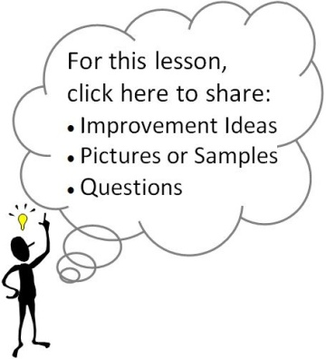
Standards and Essential Question:
- 9-CD.B5 Create short-, mid-, and long-term goals that support academic and personal growth
- 9-INQ.B1 Refine collaborative tutorial skills through tutor-led discussions following tutorial sessions
- EQ: “How can I support the success of my tutorial group?”
Materials/Notes
Class Set
AVID Tutorial Guide
3.11g Group Member Collaborative Inquiry Protocol (Pgs. 224, 228)

Lesson
- TRF Collection
  - As students enter class, collect their Tutorial Request Forms.
  - Have your tutors use the TRFs to break the students into groups, as you begin the class.

- Tutorial
  - Break students into their tutorial groups.
  - Distribute the Group Member Collaborative Inquiry Protocol handout.
  - Briefly discuss how group members can help drive the thinking and conversation during tutorials.
  - Instruct students to observe what all of the group members are doing throughout the tutorial session.
  - Fill out the strips at the end of the tutorial session.

