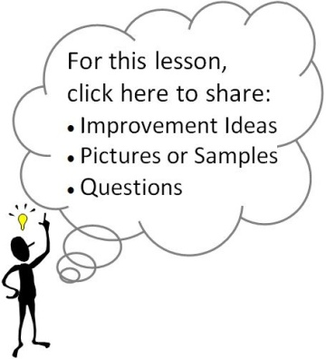
Standards and Essential Question:
- 9-WRI.C2 Develop and strengthen writing through the creation of a Mandala essay
- 9-CD.A5 Complete self-evaluations about conflict resolution, personal behavior, and core values
- EQ: “What are the core values in my life?”
Materials/Notes
Reference
High School Writing
5.1 Mandala Autobiography
(Pgs. 217-238)

Class Set
Mandala Rough Draft Template
Lesson
Note: If you are off pace at this point in the year, you can combine Day 106 and Day 108 into a single lesson.

- What is a Mandala?*
  - Have students define, “What is a Mandala?” Then, have them record ideas and show an example.
  - Have students define, “What is a symbol?”
    - If students are unable to correctly identify the meaning of a symbol, follow step 3 at the beginning of the Mandala Autobiography section.
  - Break students into groups of three and ask, “What are some things a circle can symbolize or represent?”
    - Record ideas on the board or chart paper.

- Guided Visualization and Quickwrite*
  - Look over the list below and select two or three scenarios that you would like to use in class. Adapt/adjust them to suit the needs of your students.
Documentation for Essential 6.2
    - Think about a significant day in your life: Who was there? Where were you? What was happening? Why is the day important to you?
    - Think about a series of favorite locations from throughout your childhood. These places might range from dad’s lap, to grandma’s kitchen stool, to a secret hiding place beneath a willow tree, to a national monument. As you think of these favorite locations, try to determine why each place was special and what each one represented. (You might want to offer a personal example to get students thinking.) Envision the people closest to you/most special to you. Who are they? See their faces. View their actions. What have they done or what do they do that makes them special?
    - Think about the objects in your life that are most important to you. What are they? Feel yourself holding them. How do they make you feel? Where did you get them? Why are they special?
    - Think about a difficult time in your life. What was going on? Why were you struggling? Who was there to help you up? How did you respond to the challenge?
    - See your life as a journey. What does it look like—a bumpy road, a river, etc.? Where did the journey begin? Where has it led you? Where is it heading? How has the trip been? What part of the journey might be particularly important, maybe a defining moment?
  - Have students close their eyes. Guide students through the scenario, setting the mood/tone with music, lighting, etc.
  - Have students open their eyes, while remaining silent, and create a picture or graphic display of their thoughts.
  - Have students do a quickwrite about their picture/graphic display.
  - Give students the opportunity to share their visual and quickwrite with a partner or in a triad/small group.
  - Have students store their quickwrite in a location where they can access it on Day 108.

