Standards and Essential Question:
- 9-WRI.C2 Develop and strengthen writing through the creation of a Mandala essay
- 9-CD.A5 Complete self-evaluations about conflict resolution, personal behavior, and core values
- EQ: “How do the symbols of my life connect?”
Materials/Notes
Reference
High School Writing
Mandala Essay
(Pgs. 219-221)
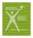

Class Set
High School Writing
5.1b The Symbols of My Life
(Pg. 232)
Mandala Template (copied on cardstock)
Presentation Rubric Strips

Materials
Colored Pens or Pencils

Lesson
- List and Share Symbols
  - Have students take out their quickwrites from Day 106.
    - If students have not completed the selected scenarios, continue the visualization steps.
  - Pass out The Symbols of My Life handout.
  - In the left column, list the things that are most important in your life.
    - For example, people, experiences, beliefs, objects, places, etc.
  - Work with a partner (or small group) and draw or describe at least one symbol to represent each of the items on the left.
  - These symbols should then be recorded in the middle column.
    - As examples, dove represents peace, heart represents love, etc.
  - Collaborate with your partner/group to find deeper meaning behind the symbols.

- Model a Mandala
  - Model a sample Mandala on the board or overhead projector using five personal symbols.
    - It can be either your own Mandala or a former student’s Mandala.
  - Place one main symbol in the center and four symbols around it.
  - Discuss or show the connecting design that holds the symbols together.
  - Discuss how the connecting design can create a unifying theme, solidify the overall message, and/or create a mood/tone.
    - For example, students might use water droplets as a connecting design throughout the Mandala because the drops represent tears and “washing away.”
    - Connecting designs might also help students later in their writing as they look for ways to transition between ideas/symbols.

- Create Mandala
Documentation for Essential 6.5, 7.7
  - Help students narrow their list by asking them the following questions:
    - If you could only highlight one symbol on your list, which would it be? This symbol should be the largest in terms of meaning. It should encompass your essence and/or the most significant thing about you.
    - What symbols, when grouped together, define the most essential elements of your life?
    - What symbol offers special/unique insights about your life?
  - Have students select five symbols from their list to create their Mandala. They should think about how the different symbols work individually, yet flow together.
  - Using unlined paper, students draw a circle and make a rough sketch of their Mandala, putting the most important symbol in the middle.
    - This should be done quickly, and students should not focus on artwork.
  - Remind students about the connecting design in the model Mandala.
  - Working in small groups, complete the following:
    - Students should share their rough sketch, explaining their symbols and clarifying how it “tells their story.”
    - Peers offer feedback about the symbols and order.
    - All group members brainstorm ideas for a connecting design.
    - Following the discussion, the student selects his/her design.
  - Distribute pencils, colored markers, and scissors.
  - Provide each student with the Mandala Template on the cardstock.

- Homework
  - Tell students that they will present their Mandalas in a one- or two-minute speech to the class on Day 110.
    - Encourage students to think about focusing on their voice and purposeful movement during the speech
    - Assign ordering, as necessary.
    - Pass out Presentation Rubric Strips and inform students that they will be working on eye contact and volume during this presentation.

- Technology Extension*
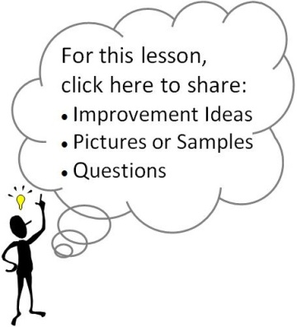
  - Have students use a site such as www.storybird.com to write and illustrate their essays.

