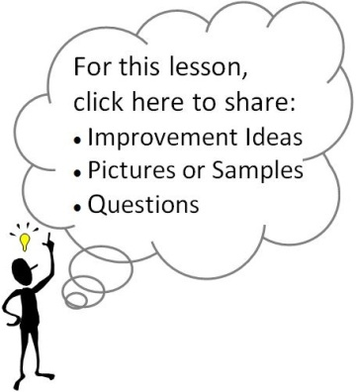
Standards and Essential Question:
- 9-WRI.A3 Revise drafts multiple times to improve and clarify
- 9-WRI.B4 Include descriptive sentences in pieces of writing
- 9-WRI.C2 Develop and strengthen writing through the creation of a Mandala essay
- EQ: “What do I want my reader to know about me that I can convey through this essay?”
Materials/Notes
Reference
High School Writing
5.1a-d Student Samples: Mandala Essays (Pgs. 235-238)

Class Set
Guiding Questions

Lesson
Note: If possible, reserve the school’s computer lab for the writing of this essay.

- Essay Drafting
  - Have students take out their outline and Mandala.
  - Have students type up a draft of their Mandala essay.
    - Remind students that this is a first draft, and they should not be concerned about producing a finished, polished piece of writing.
    - Even though this is a quick, tentative, and exploratory first draft, students should write a complete draft.
  - Questions that can guide students who are stuck on the introduction include:
    - What must I know about you or your life to understand/be introduced to the rest of the paper?
    - What story would introduce me to the symbols in your Mandala?
    - What message do you want to leave in my mind when I finish your paper? How can you establish that message (theme) here?
    - How do you want me to feel at the end of your paper? How can you establish that feeling here?
    - How might your connecting design set up an introduction idea?
    - What is your paper really about? Is it a struggle? Triumph? Hope? Despair?
    - Do you have a unifying theme or message in mind?
  - Questions and ideas that can guide students who are stuck on their body paragraphs include:
    - What is your major idea for this symbol? What is important about it? Why did you choose it?
    - Read your last paragraph aloud, and then start writing the next paragraph.
    - Tell me what you’re trying to say in this paragraph. (Scribe while student speaks.)
  - Questions that can guide students stuck on the conclusion include:
    - How do all of the symbols in your Mandala come together to create a whole story?
    - What growth/development did you experience?
    - What is the message behind the symbols? How can you make it explicit?

- Homework
  - Every student must have a printed essay for Day 116.
Documentation for Essential 6.3

