What Is AVID?
AVID is a fourth- through twelfth-grade system to prepare students in the academic middle for four-year college eligibility. These are students who are capable of completing a college-prep curriculum but may be falling short of their potential. The core component is the AVID elective, which supports students as they tackle the most rigorous classes. AVID’s teaching strategies, curriculum, and trainings are used not only in the AVID elective class, but by subject-area teachers schoolwide.
AVID STUDENTS
AVID students are enrolled in a school’s toughest classes, such as Advanced Placement, and attend an academic elective class-called AVID-taught within the school day by a trained AVID teacher. The three main components of the program are academic instruction, tutorial support, and motivational activities. Their self-images improve and they become academically successful leaders and role models for other students. They are proud to be in the program.
Parents
Parents encourage their students to achieve academically, participate on an advisory board and in AVID parent and site team meetings, and maintain regular contact with the AVID coordinator. Many parents and students participate in AVID Family Workshops.
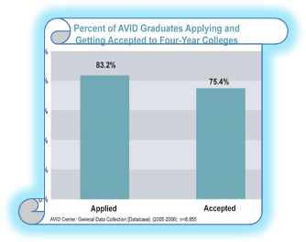
Results
AVID students are more likely to take AP classes, complete their college eligibility requirements, and get into four-year colleges than students who don’t take AVID.
Almost all AVID students who participate for at least three years are accepted to college, with roughly three quarters getting into four-year universities.
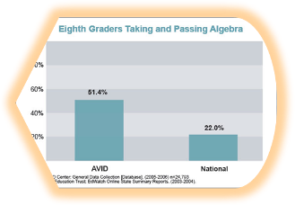
AVID also helps ensure that students, once accepted to college, possess the higher-level skills they need for college success.
Curriculum
The AVID curriculum, based on rigorous standards, was developed by middle and senior high school teachers in collaboration with college professors. AVID is based on writing as a tool of learning, the inquiry method, collaborative grouping, and academic reading.
Many AVID students complete high school algebra while in middle school. We know that students who take high school algebra while in middle school, enter high school with an advantage with regard to credits and academics.
Interested In Joining AVID?
Visit your guidance counselor, and find out how you can join to become a part of the AVID family!

